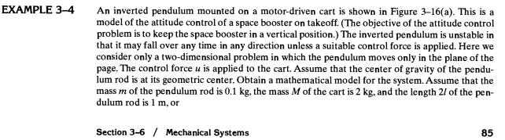

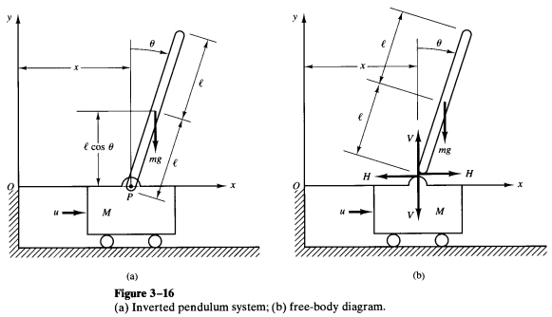

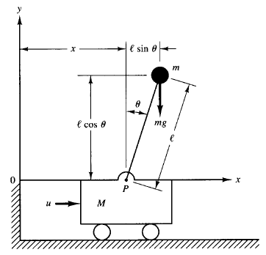

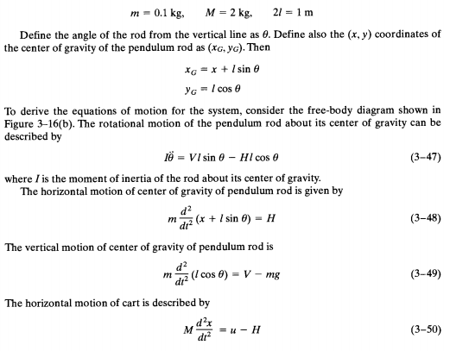

Note:

Moment of inertia ($I$) is a physical quantity that measures how much an object resists rotational acceleration about a particular axis. It is sometimes described as the rotational equivalent of mass for linear motion.
- Mathematically, for a point mass:
$$I=mr^{2}$$
where $m$ is the mass and $r$ is the distance from the axis of rotation.
The greater the moment of inertia, the harder it is to change the object's rotational speed.

In the above derivation,
  - $V$: vertical force at the pivot; $H$: horizontal force at the pivot.

The moment of inertia $I$ directly affects how the angular acceleration $\ddot{θ}$ responds to torques from forces $V$ and $H$. A larger $I$ means the same force results in smaller angular acceleration, making the pendulum harder to tip or swing.

- For a rod pivoted at its centre, $I=\frac{1}{12}mL^{2}$ (with $L$ being the full rod length).

Understanding $I\ddot{θ}$: Significance and Origin

- I is the moment of inertia of the pendulum rod about its centre of gravity.
- $\ddot{θ}$ (read as "theta double dot") is the angular acceleration—the second derivative of the angle $θ$ with respect to time (i.e., how quickly the rotation's speed is changing).
- Thus, their product $I\ddot{θ}$ is rotational inertia times angular acceleration, which gives the net torque acting on the pendulum.

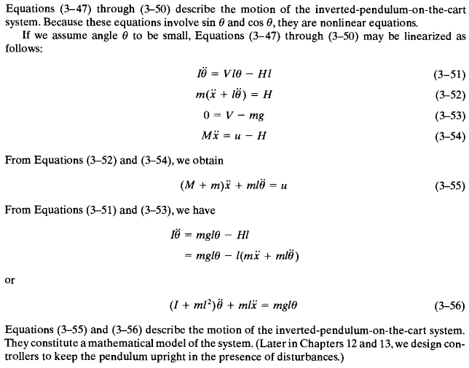

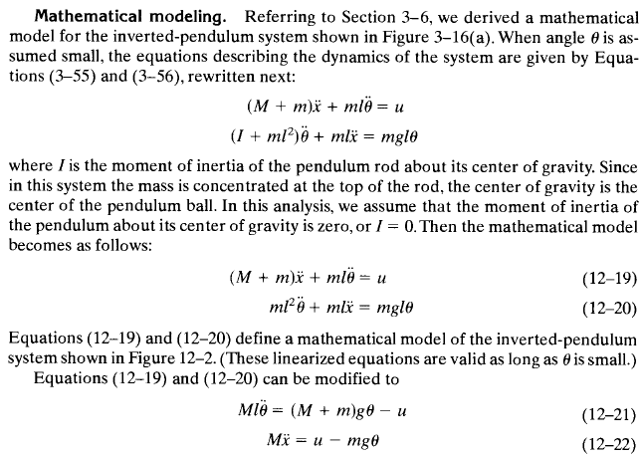

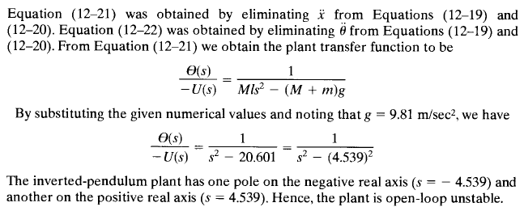

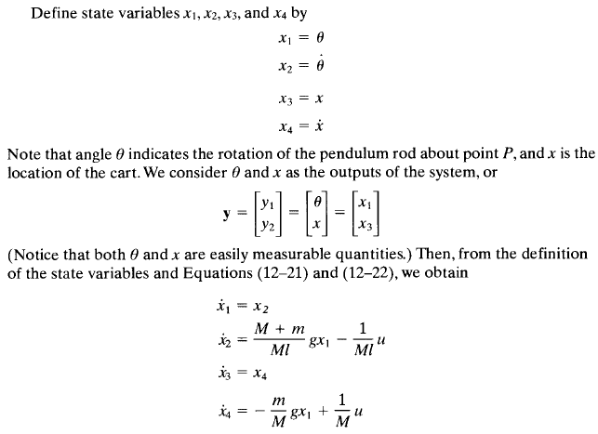

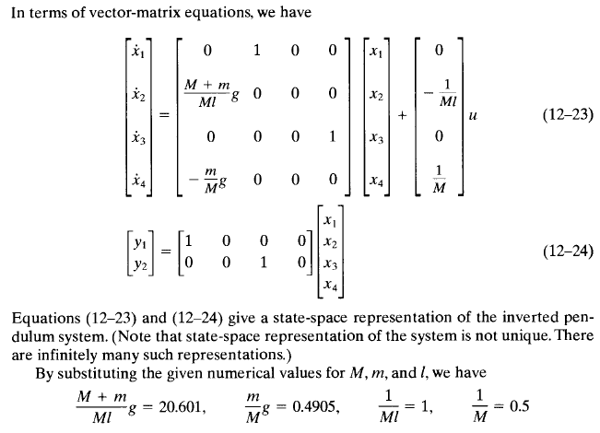

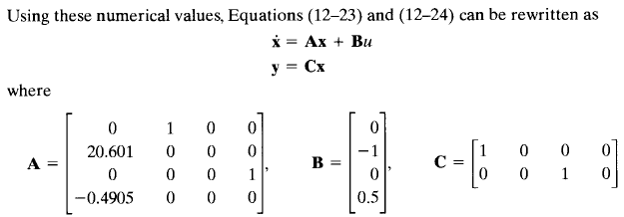

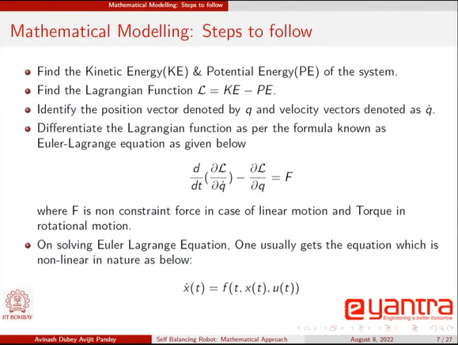

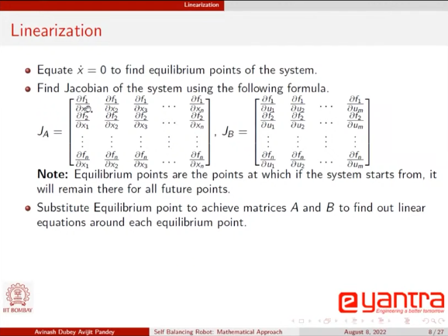
The functions f1, f2, f3, f4… are the mathematical expressions of each of the derivatives of the state vectors x1, x2, x3,…
Also, while finding the equilibrium points of the system, all the inputs in the model equations should be taken as zero.

